DESIGN OF AN IOT SYSTEM FOR MONITORING AND EARLY WARNING OF TILTING AND SUBSIDENCE IN HIGH VOLTAGE ELECTRICAL EQUIPMENT
Pham Ngoc Luat¹*, Tran Huu Danh¹, Tran Nguyen Hien² and Tran Thanh Quang¹
¹ Faculty of Electronics and Telecommunications, Can Tho University
² Student of the Faculty of Electronics and Telecommunications, Can Tho University
*Corresponding author, email: pnluat@ctu.edu.vn
Article info:  Received: dd/mm/yyyy  Revised: dd/mm/yyyy  Accepted: dd/mm/yyyy  Keywords: Tower Inclination, Dashboard, ESP32, IoT, | - ABSTRACT  - This paper presents ...

1. INTRODUCTION
Along with advances in science and technology, the application of automated machinery to production processes—and specifically to equipment condition monitoring—has become increasingly widespread. Automated monitoring solutions are now deployed across a variety of industries. In Vietnam, several studies have explored structural tilt and settlement monitoring. For instance, Luong Ngoc Dung et al. [1] introduced Tiltmeter monitoring technology, detailing its measurement, calculation, and analysis methods, while comparing it with horizontal distance measurement for vertical structural tilt and geometric leveling. Additionally, Luong Ngoc Dung [2] presented the application of inclinometer technology in confined spaces. However, these methods are primarily tailored for structural tilt monitoring in civil engineering construction.
To the best of the authors' knowledge, there is currently no specific domestic research on the design of IoT-based early warning systems for monitoring the tilt and settlement of electrical equipment in 220kV and 500kV substations.
The application of automation to monitoring and evaluating the tilt and settlement of high-voltage transmission towers has also drawn significant attention from the global research community. Ruhai Liu et al. [3] proposed an online tilt monitoring method for transmission towers using images and point clouds acquired by Unmanned Aerial Vehicles (UAVs). Based on this approach, a multi-scale classifier was constructed to automate the classification of point cloud data, thereby determining tower tilt. Subsequently, Yongseng Yang et al. [4] suggested a camera-based tilt monitoring method that relies on the geometric shape and contour of the towers. Additionally, Zhumao Lu et al. [5] presented a study using UAV-mounted LiDAR to assess tower tilt status based on point clouds from the tower top and body. Guangxin Zhang et al. [6] proposed a real-time monitoring method for transmission tower tilt and foundation stability based on acceleration sensors. Furthermore, Liuhuo Wang et al. [7] developed a solution using an excitation device, wireless sensors, and a monitoring server to record the horizontal vibrations of power line towers. However, these studies rely on complex computational models and require high initial investments for data acquisition equipment.
Substations operating at 220kV and 500kV play a crucial role in the national power transmission grid. These substations are surveyed, designed, constructed, and commissioned in full compliance with governmental and industry regulations. However, during operation, certain equipment—such as disconnect switches, post insulators, current transformers, and voltage transformers—can experience tilt and settlement due to shifts in site layout and column foundations. When any of this equipment tilts, the busbar and conductor connections within a bay are altered; conductors may become overly taut or sagged, ultimately compromising the long-term operational integrity of the equipment. Therefore, continuous monitoring, assessment, and early warning of equipment tilt and settlement sent to station operators are essential to ensuring a safe, uninterrupted power supply. This study applies automation technology to power transmission grid operation management, thereby contributing to enhanced labor productivity and national energy security.
This study successfully designed an IoT-based system for early monitoring and warning of equipment foundation tilt and settlement in 220kV and 500kV substations, enabling timely corrective measures to ensure the safe operation of high-voltage electrical equipment. The system can transmit continuous real-time updates and send alerts - including equipment identity, tilt status, location, and timestamp - to the monitoring center via the Internet.
2. RESEARCH METHODOLOGY
2.1. System overview
Figure 1 shows the overall system diagram.

XXXXXX [Hien]

Figure 1. Overall system diagram
As shown in Figure 1, the system architecture consists of the following key functional modules:
- Power Supply Module: Employs 3.7 VDC 18650 lithium-ion batteries connected in series to provide an equivalent 12 VDC supply. ……………………….
- Data Processing Module: Centered around an ESP32 microcontroller that acquires raw field data from the MPU6050 sensor (powered at 3.3 VDC), …………………..
- Display Module: Uses an OLED …………………...
2.2. System hardware design
2.2.1. Master module
Figure 2 describes schematic diagram of the master module. [Hien]
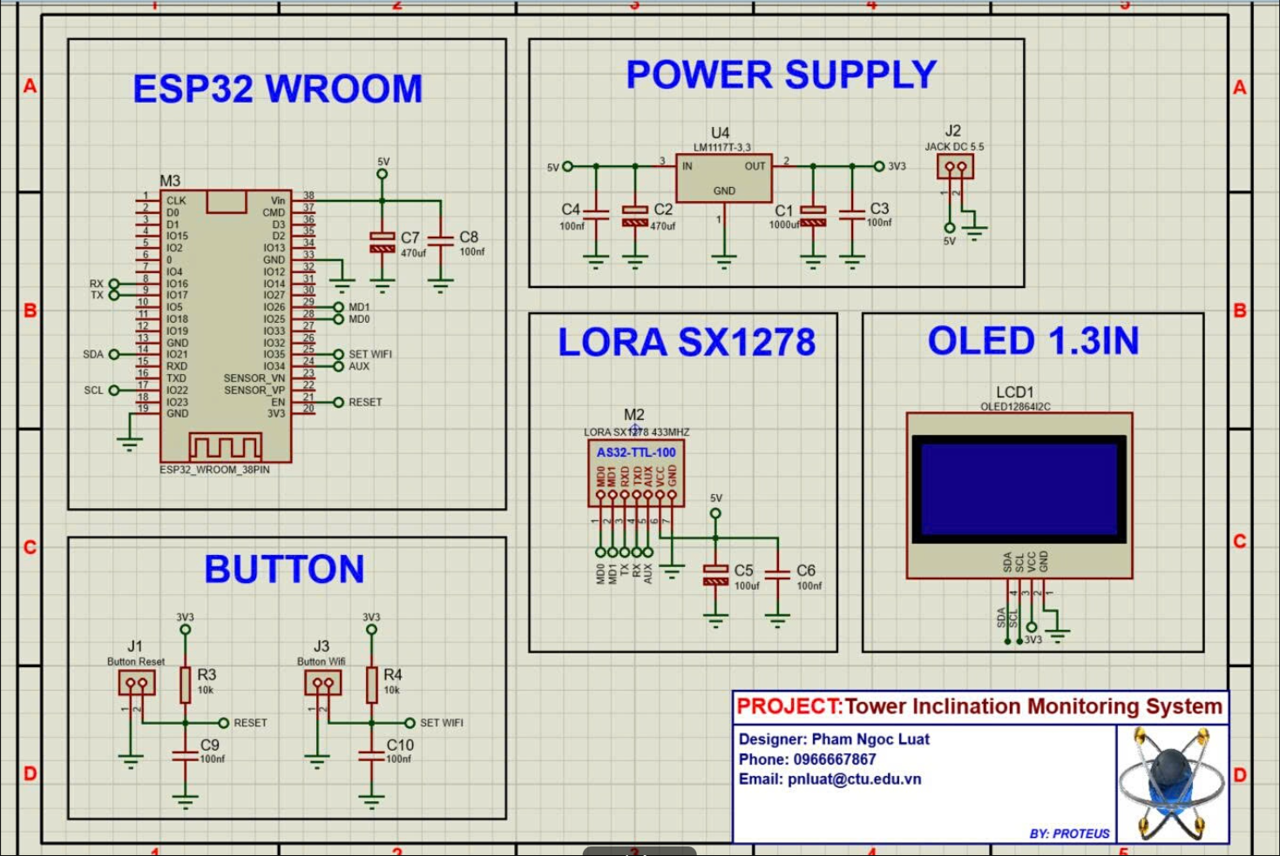
Figure 2. Schematic diagram of the master module
The block diagram and hardware configuration of the central gateway (Master Node) are illustrated in Figure 2. The gateway serves as a communication hub that collects wireless data from distributed sensor nodes and forwards it to the central management system. The circuit relies on an ESP32 WROOM microcontroller as the core processing unit, responsible for receiving data via a LoRa SX1278 module (AS32-TTL-100 IC, 433 MHz frequency) and processing it before transmission to the server over Wi-Fi connection. Real-time operational parameters and network status are locally displayed on a 1.3-inch OLED screen using the I2C communication protocol. The power supply unit receives a 5V DC input via a 5.5mm DC jack and employs an LM1117T-3.3 linear regulator alongside filtering capacitor networks (1000μF, 470μF, 100nF) to deliver a stable 3.3V rail for the microcontroller and peripheral components. Additionally, a dedicated button block consisting of Reset and Wi-Fi Configuration buttons allows operators to easily reboot the system or reconfigure network parameters.

2.2.2. Node module
Figure 3 illustrates the schematic diagram of the node module. [Hien]
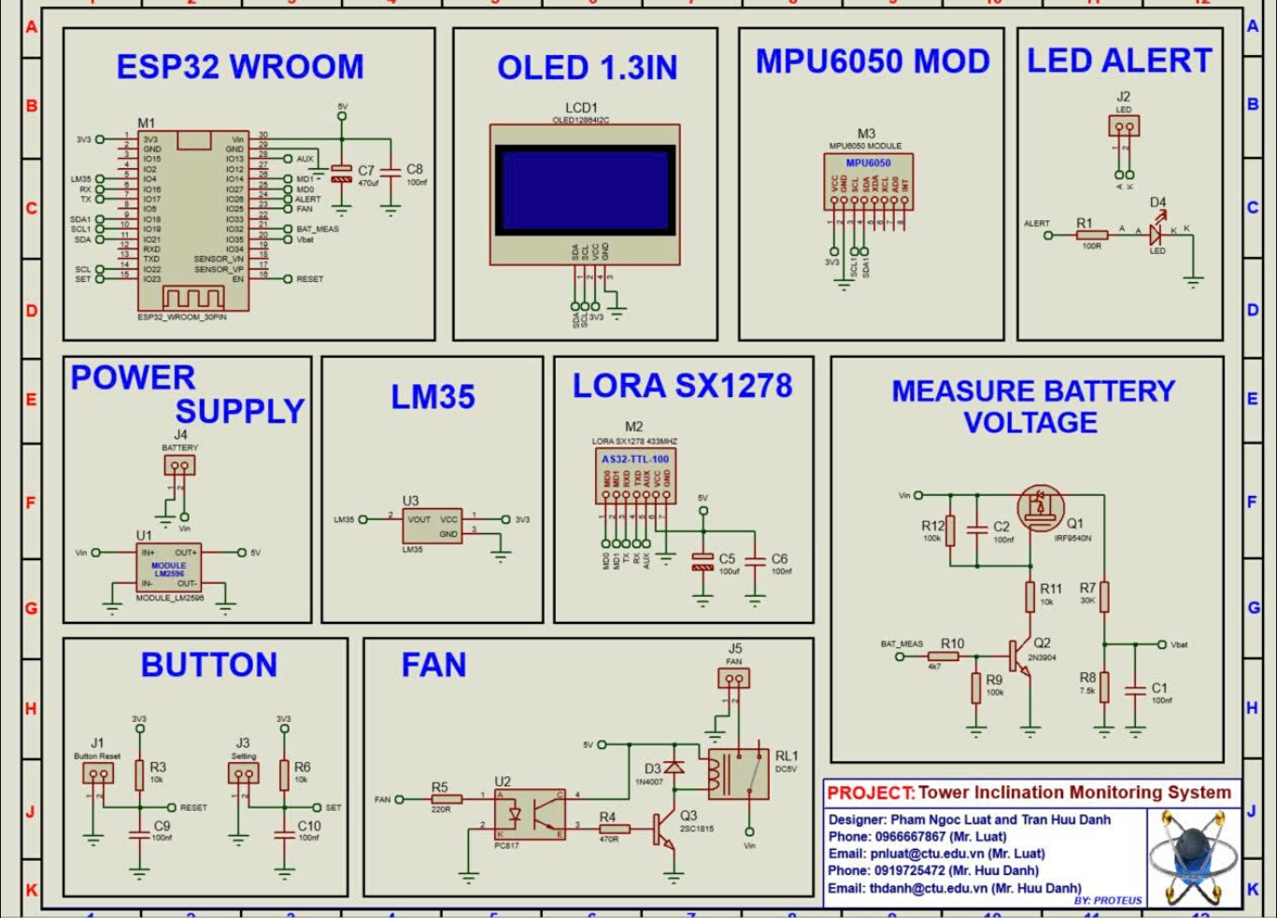
Figure 3. Schematic diagram of data processing and sensor module
The block diagram and operational principle of the inclination monitoring node are illustrated in Figure 3. The system utilizes an ESP32 WROOM central microcontroller for data acquisition, algorithmic processing, and communication management. Regarding data collection, the three-axis (X, Y, Z) inclination variations of the structure are captured via an MPU6050 6-axis accelerometer and gyroscope sensor connected through the I2C protocol. Concurrently, the ambient temperature inside the technical enclosure is monitored using an LM35 analog sensor. Once processed, the data is displayed directly on a 1.3-inch OLED screen and packaged for long-range, low-power wireless transmission to the central gateway via a LoRa SX1278 module (AS32 IC, 433 MHz frequency band).
To ensure system reliability and long-term operation, the node integrates a power management unit and automatic actuation circuitry. Primary power supplied from a battery or accumulator is stepped down to a stable 5V output using an LM2596 module. The battery voltage measurement circuit is specifically designed with an NPN transistor (2N3904), a P-MOSFET (IRF9540N), and a voltage divider (30 kΩ/ 7.5kΩ). This configuration enables the microcontroller to periodically trigger the measurement circuit via the Vbat pin and read the value through an ADC channel (BAT_MEAS), effectively eliminating static leakage current to optimize power consumption. Furthermore, if the measured inclination angle exceeds the safety threshold, the microcontroller triggers an LED indicator (D4). In cases where the internal temperature surpasses a predefined limit, a control signal from the FAN pin energizes a relay through an optocoupler (PC817) isolation circuit and a transistor (2SC1815) to operate a 5V cooling fan, ensuring stable system operation under harsh environmental conditions.
2.3. System software design
2.3.1. Web dashboard flowchart
Figure 5 illustrates the Web Dashboard architecture based on the ESP32 → Google Sheet → Supabase → Node.js Server → MySQL → Website model.
Hien

Figure 5. The flowchart algorithm for displaying data on the Web Dashboard
………………………………………………………………………………………………………………………………………… [Hien] …………………………………………………………………………………………………………………………………………………. without requiring a full page refresh.
2.3.2. System flowchart
Figure 6 describe the operation of the system.
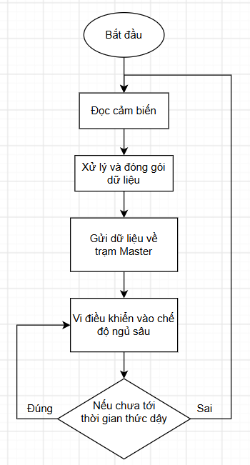
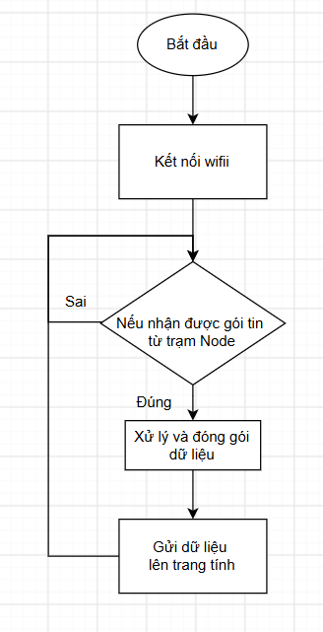
Figure 6. Operation flowchart algorithm
Upon power-up, ……………………………………………………………………………………………………………………………………………………………………………………………………………….
2.3.3. Web interface
Figure 7 shows the Web Dashboard interface of the system.
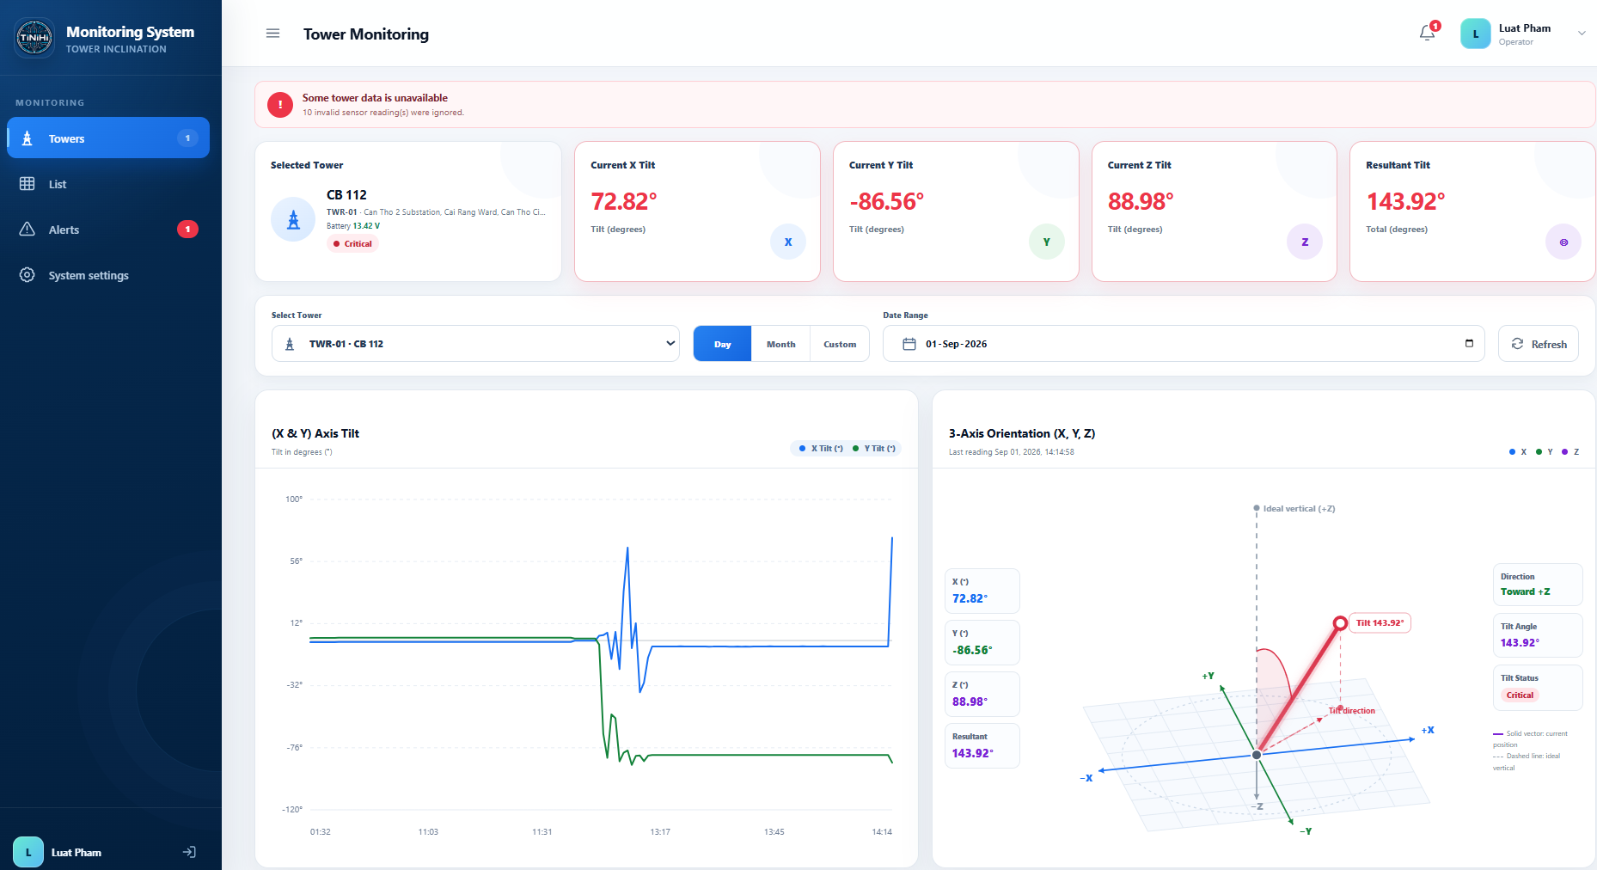
Figure 7. Web dashboard interface
In this interface, ……………………………………………………………………………………………………………………………..
3. EXPERIMENTAL RESULTS
3.1. Complete system
Figure 8 shows the complete system with all components.
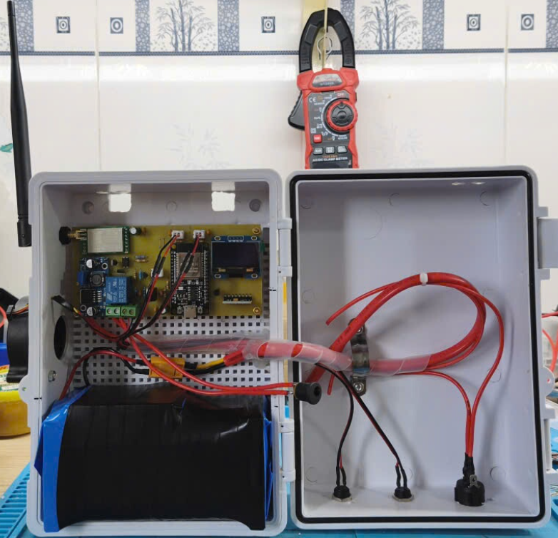
Hình này sẽ thay thế khi có lắp mạch sạc
(a)
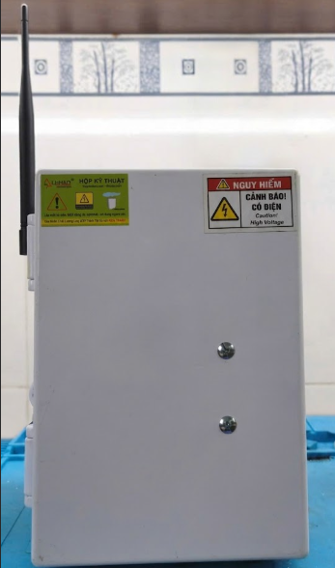
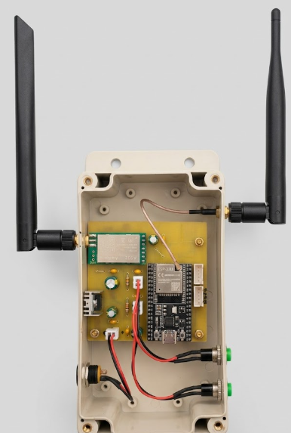
(b)
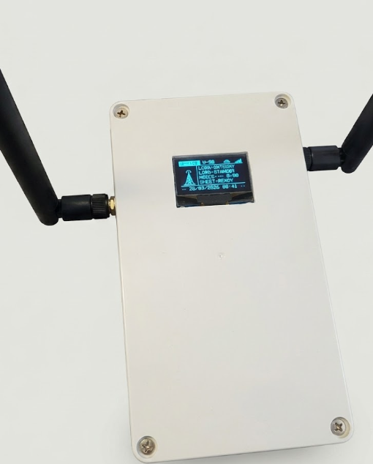
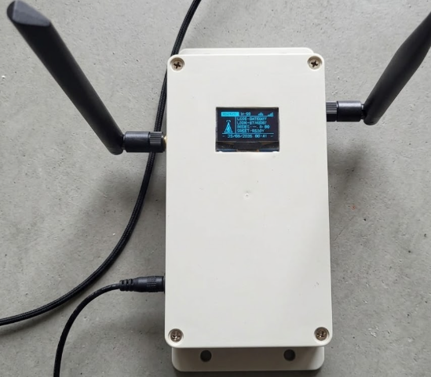

Figure 8. Complete system
The ………………………………………………………………………………………………………………………………………………………………………..
3.2. System operation check
3.2.1 Scenario 1
In the first practical field test inspecting ………….. and the Web Dashboard are shown in Figure 9.

(a)

(b)

(c)
Figure 9. Testing case 1: a) testing position; b) detail information of the tower on the Web dashboard
The testing position shown in Figure 9a is …………………………..
3.2.2 Scenario 2
In the second practical field test inspecting ………….. and the Web Dashboard are shown in Figure 10.

(a)

(b)

(c)
Figure 10. Testing case 2: a) testing position; b) detail information of the tower on the Web dashboard
The testing position shown in Figure 10a is …………………………………..
3.3. System evaluation
Phần này đánh giá khả năng truyền nhận gói tin từ Master đến Node …..
Đánh giá sau xxx Ngày lắp đặt
…………………………………………………………………………………………………………………………………………………………………………………………………………………………………………………...
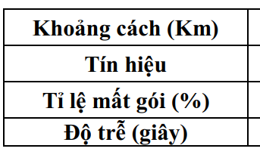

5. DISCUSSION
…………………………………………………………………………………………………………………………………………………………………………………………………………….
6. CONCLUSION

………………………………………………………………………………………………………………………………………………………………………………………………………………………………………………………..

Acknowledgement
The authors would like to acknowledge the support of time and facilities from Can Tho University (CTU) for this study under contract number T2026-69 dated June 1, 2026.

References

- L. Pang, Y. Xie, H. Yang, M. Li, X. Bao, J. Shang and R. W. Li. Flexible Magnetic Sensors. MDPI Sensors. 2023. Vol. 23, pp.4083. doi: 10.3390/s23084083.
- X. Meng, M. Lu, W. Yin, A. Bennecer, & J. K. Kirk. Evaluation of coating thickness using lift-off insensitivity of eddy current sensor. MDPI Sensors. 2021. Vol.21, Issue 2, pp.419.
- S. Hassani and U. Dackermann. A systematic review of advanced sensor technologies for non-destructive testing and structural health monitoring. MDPI Senors. 2023. Vol 23. Pp. 2204. Doi: 10.3390/s23042204.
J. G. Martin, J. G., Gil, E. V. Sanchez. Non-destructive techniques based on eddy current testing. MDPI Sensors. 2011. Vol.11, pp. 2525-2565. doi:10.3390/s110302525.
- Y. Cheng, Y. Chen, & B. Zhang. Absorbing coating thickness measurement based on lift-off effect of eddy current testing. International Journal of Applied Electromagnetics and Mechanics. 2014. Vol.45, Issue 1-4, pp.323-330.
V. Marsic, P. Igic, V. Pandey, W. Zhou, S. Faramehr. Experimental low-cost magnetic scanning for non-destructive testing with hall sensors: Determining material’s thickness. IEEE Access. 2025. vol. 13, pp. 65105-65120, doi: 10.1109/ACCESS.2025.3560025.
Mvtek. ISO standard guide to measuring paint coating thickness. 2025. https://mvtek.vn/huong-dan-do-do-day-lop-phu-son-chuan-iso.html
- Shenzhen GVDA Technology Co.Ltd. Common coating thickness gauges faults and how to fix these. 2024. https://www.gvda-instrument.com/info/common-coating-thickness-gauges-faults-and-how-96514904.html
- G. Zhao, Y. Huang, W. Zhang, C. Wang, & J. Chen. Advances in high-precision displacement and thickness measurement based on eddy current sensors: A review. Measurement. 2025. Vol.243, pp.116410.
- ISO 1461:2022. Hot dip galvanized coatings on fabricated iron and steel articles — Specifications and test methods. 2022. https://www.iso.org/standard/81435.html

THIẾT KẾ HỆ THỐNG IOT GIÁM SÁT VÀ CẢNH BÁO SỚM HIỆN TƯỢNG NGHIÊNG LÚN THIẾT BỊ ĐIỆN CAO ÁP
  - TÓM TẮT

Bài báo trình bày …………………………………………………………………
Từ khóa: Bảng điều khiển, ESP32, IoT, Cảm biến gia tốc, Đo độ nghiêng.

